1. Run the file “itext-rups-5.5.3.exe”.
2. In left top corner of the program window click on icon

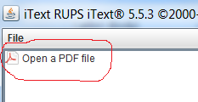

1. Choose the needed PDF file

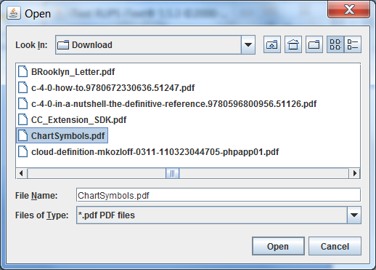

1. Wait for file loading.

You’ll get something like following

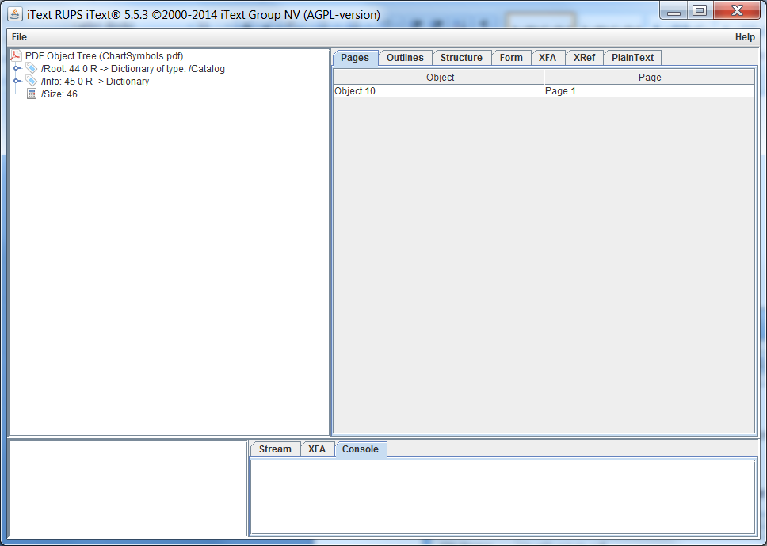

To see the information about layers and features open the tab “Structure” on the right pane.

You’ll get for the file “ChartSymbols.pdf” two layers with the same name (red bound), only one of them (below) has features (green bound):

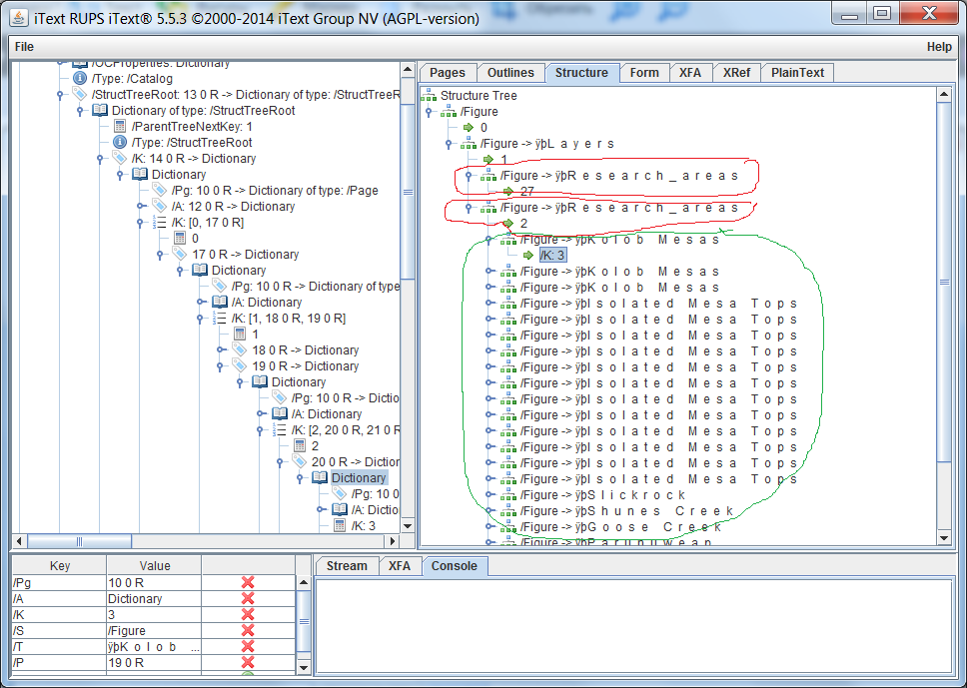

The name “Figure” means just the type of the node.

If the file is small you can see its graphical stream. If you are interesting I can explain how to do this. But you’ll need to know PDF stream operators to understand this. So I think the structure tree is enough.